

**THE UNIVERSITY OF TEXAS AT ARLINGTON, TEXAS  
DEPARTMENT OF ELECTRICAL ENGINEERING**

**EE 5321 - 001**

**OPTIMAL CONTROL**

**HW # 4**

**ASSIGNMENT**

**by**

**SOUTRIK MAITI**

**1001569883**

**Presented to**

**Prof. Michael Niestroy**

**March 29,2018**

**Problem 1:**

*Simulink diagram of SRAM*

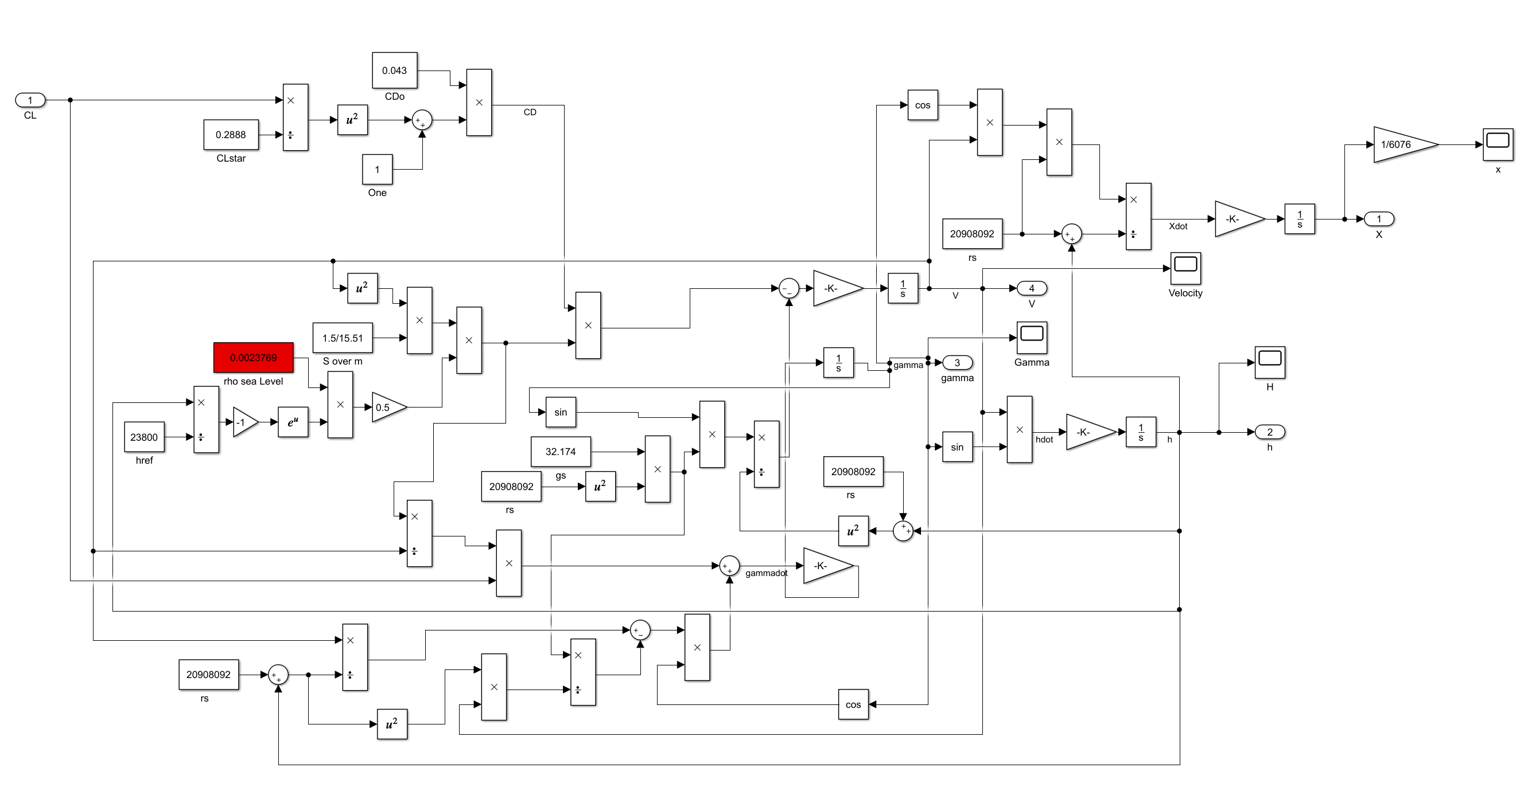

1. *Sram_main MATLAB code*

tfinal = 40 / 100;

tau = 0:0.02:1;

CL=ones(length(tau),1)*(-0.2);

CL(end+1) = tfinal;

lb=ones(length(tau),1)*(-pi);

ub=ones(length(tau),1)*pi;

lb(end+1)=0.01;

ub(end+1)=1;

options = optimset('Display','iter','TolCon',1e-3,'Algorithm','interior-point','PlotFcns','optimplotx','MaxFunEvals',2500);

[CL_final, cost] = fmincon('sram_cost', CL,[],[],[],[],lb,ub,'sram_constraint',options);

tfinal=CL_final(end);

[tout,yout]=sim('SRAM',1,[],[tau' CL_final(1:end-1)]);

figure

plot(yout(:,1)/6076,yout(:,2));grid;xlabel('X, nm');ylabel('h');

figure

plot(tau*CL_final(end)*100,CL_final(1:end-1));xlabel('Time, sec');ylabel('Final CL');grid

figure

plot(tau*CL_final(end)*100,yout(:,4));xlabel('Time, sec');ylabel('Velocity, ft/sec');grid

*sram_cost MATLAB file*

function y = sram_cost(p)

assignin('base', 'tfinal', p(end));

tau=[0:0.02:1]';

u=[p(1:end-1)];

[tout,yout]=sim('SRAM',1,[],[tau u]);

y = 0.0 - yout(end,4) / 11000; % maximum final velocity

end

*sram_constraint MATLAB file*

function [cineq, ceq] = sram_constraint(p)

cineq = [];

assignin('base', 'tfinal', p(end));

tau=[0:0.02:1]';

u=[p(1:end-1)];

[tout,yout]=sim('SRAM',1,[],[tau u]);

ceq(1) = (yout(end,1) - 72*6076) / 500000;

ceq(2) = yout(end,2) / 100000;

end

*The plots are as follows:*

*Height vs distance*

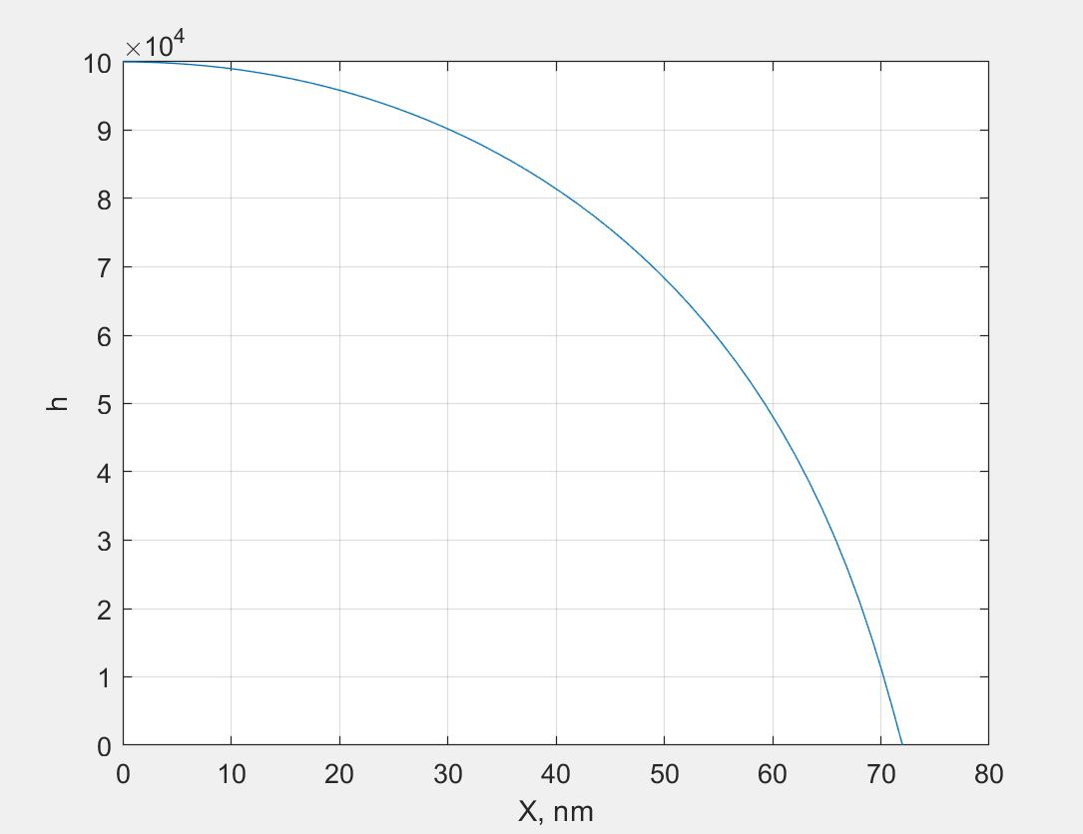

*Velocity as a function of time*

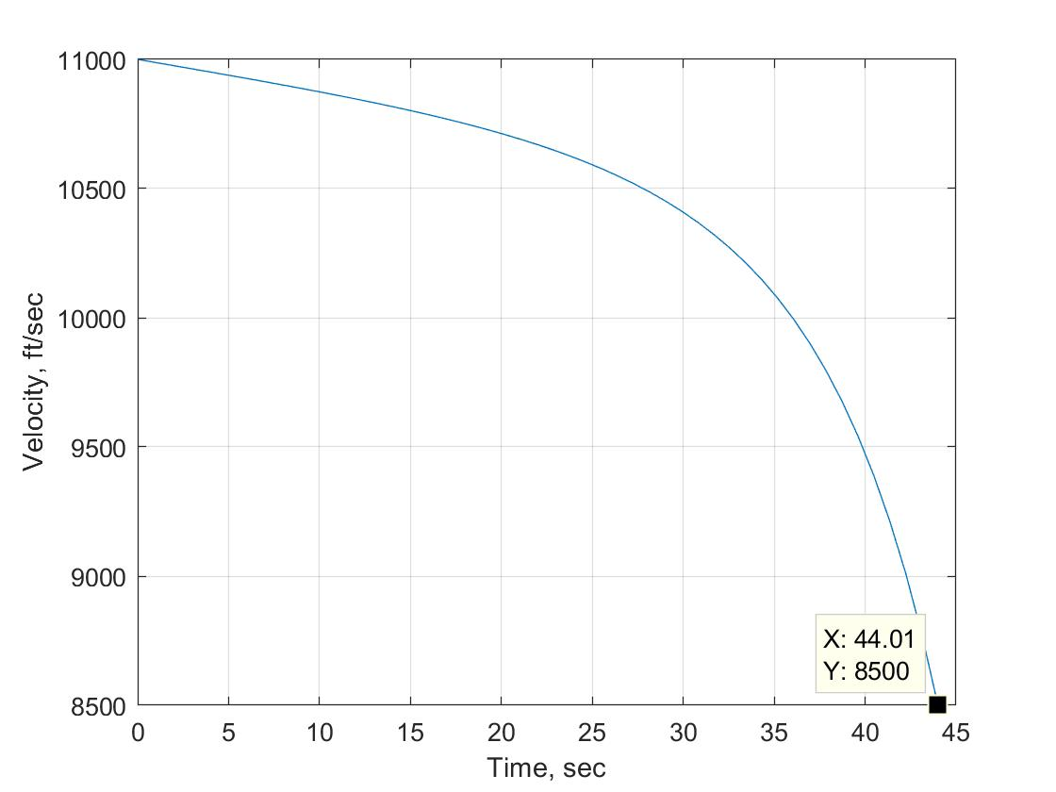

*Flight path angle in degrees*

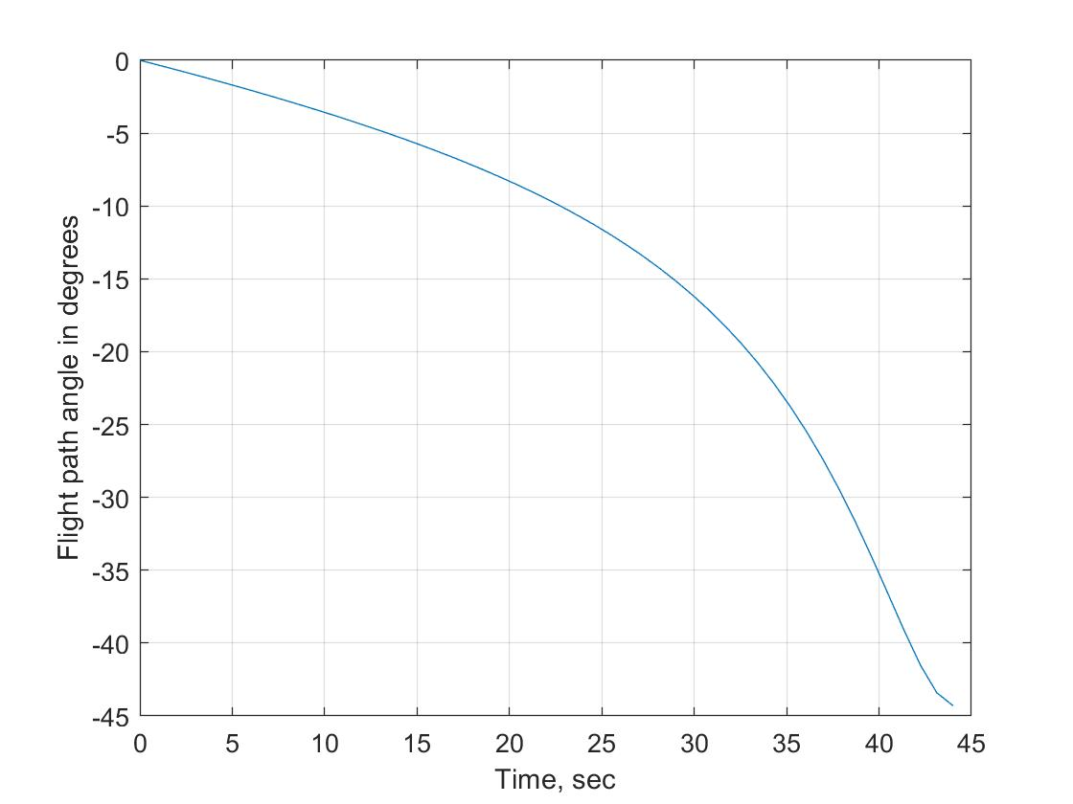

*Flight control vs time*

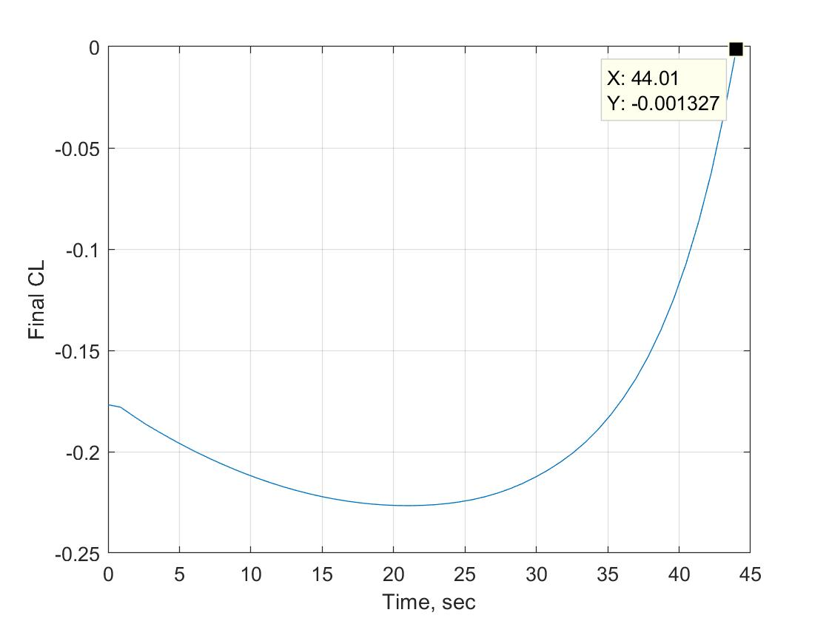

1. The only change that occurs for this part is the cost function which is as follows:

*sram_cost MATLAB file*

function y = sram_cost(p)

assignin('base', 'tfinal', p(end));

tau=[0:0.02:1]';

u=[p(1:end-1)];

[tout,yout]=sim('SRAM',1,[],[tau u]);

y = p(end); % minimum final time

end

*The plots are as follows:*

*Height vs distance*

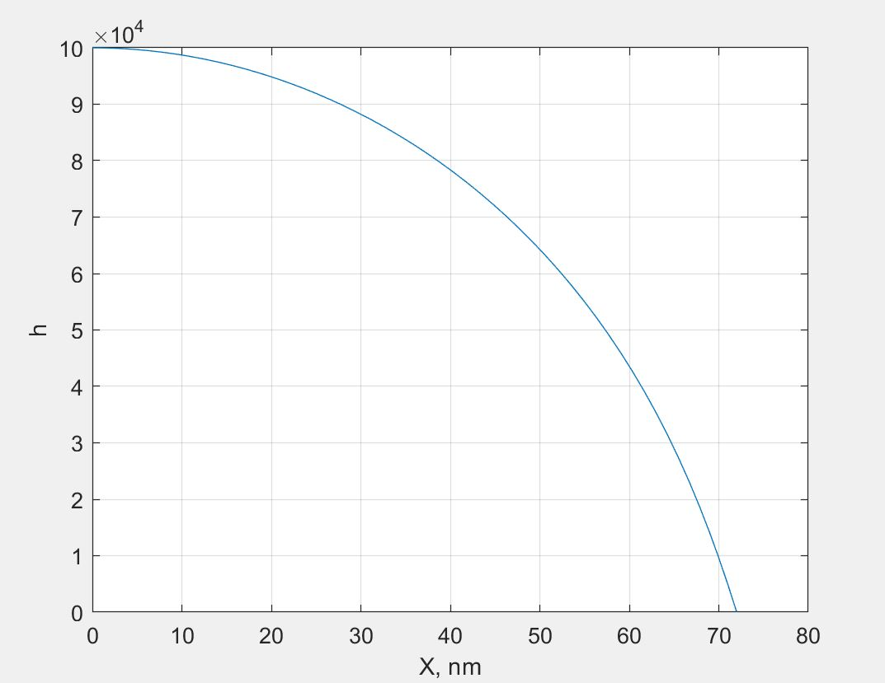

*Velocity as a function of time*

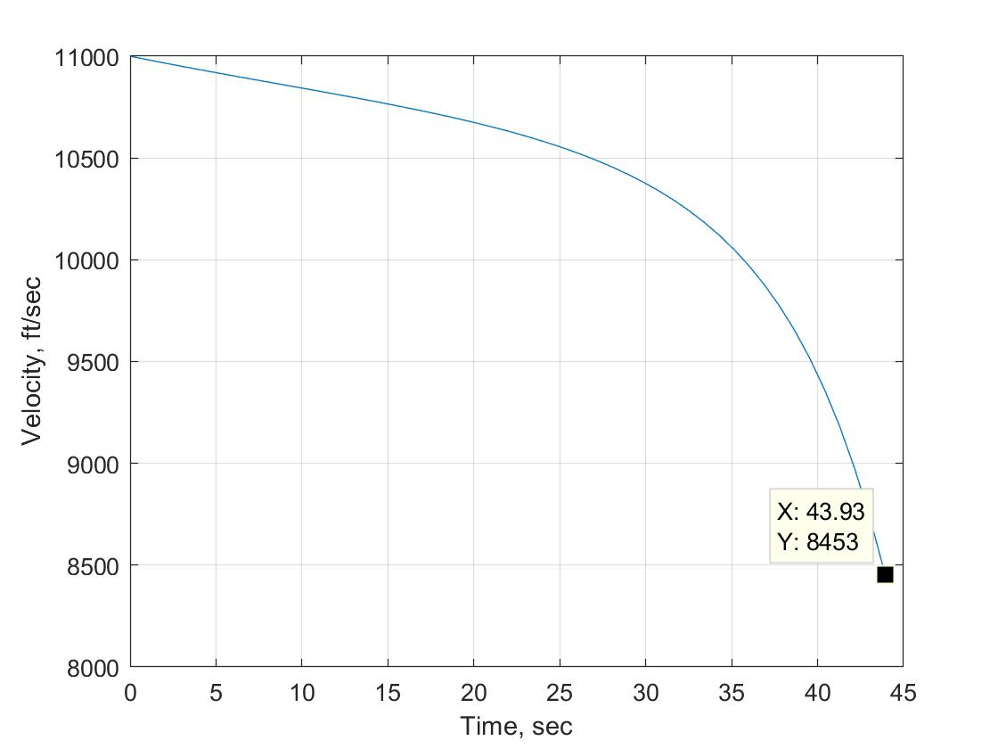

*Flight path angle in degrees*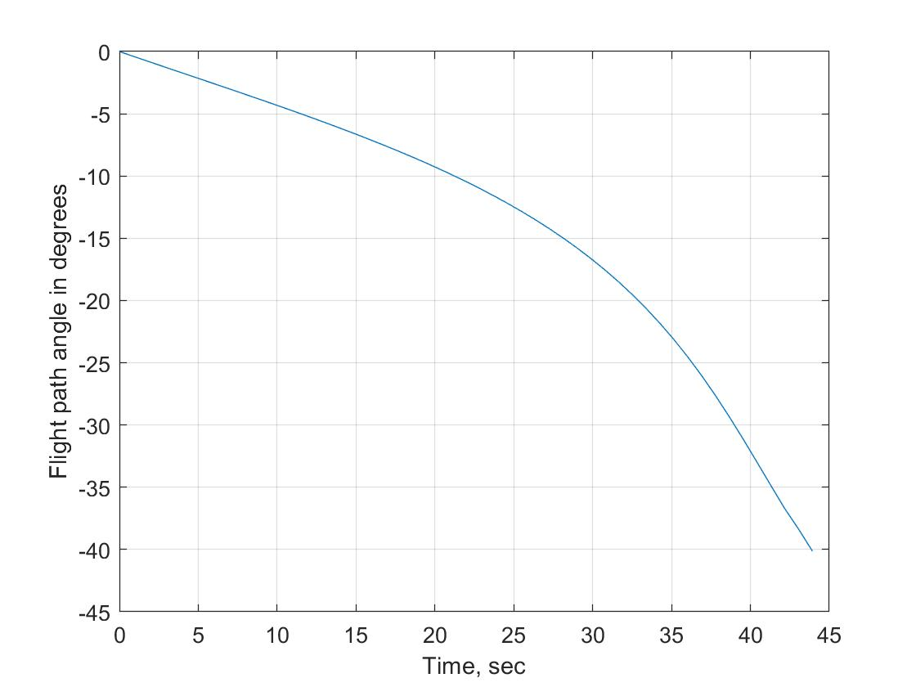

*Flight control vs time*

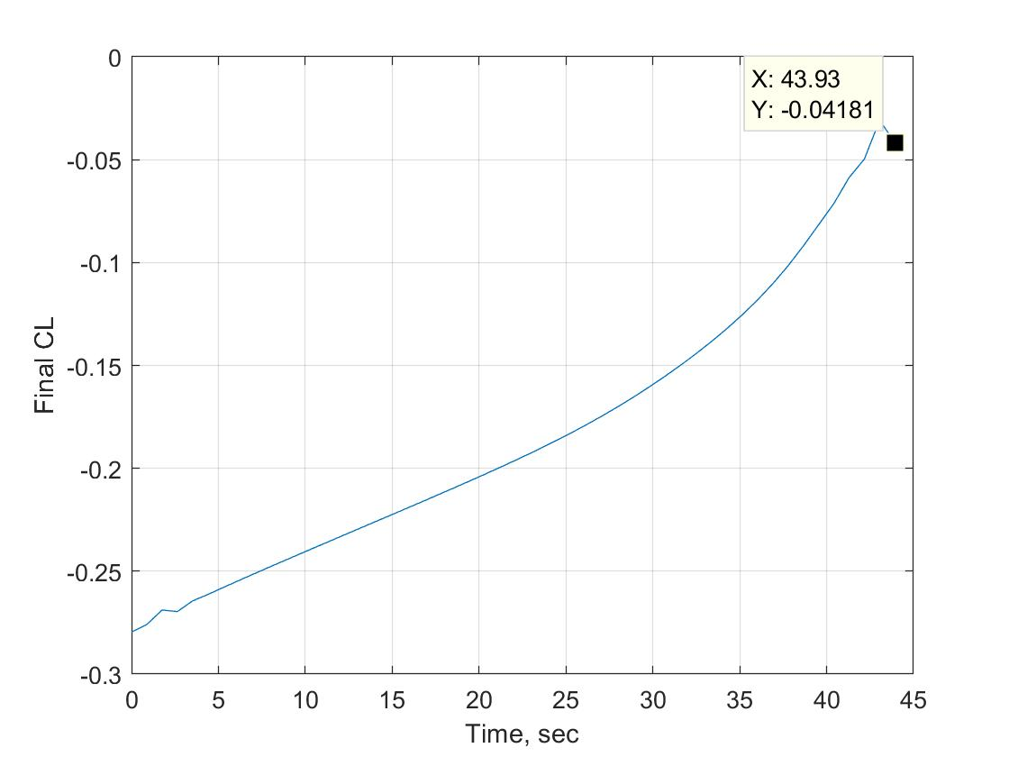

c)

|  |  |
| --- | --- |
| Final velocity | Final time |
| Part a) 8500(*Maximum velocity*) | 44.01 |
| Part b) 8453 | 43.93 (*Minimum time*) |

d)

case 1-When the atmospheric density is changed to *0.0023769*0.9* then we get the following plots:

*Height vs distance*

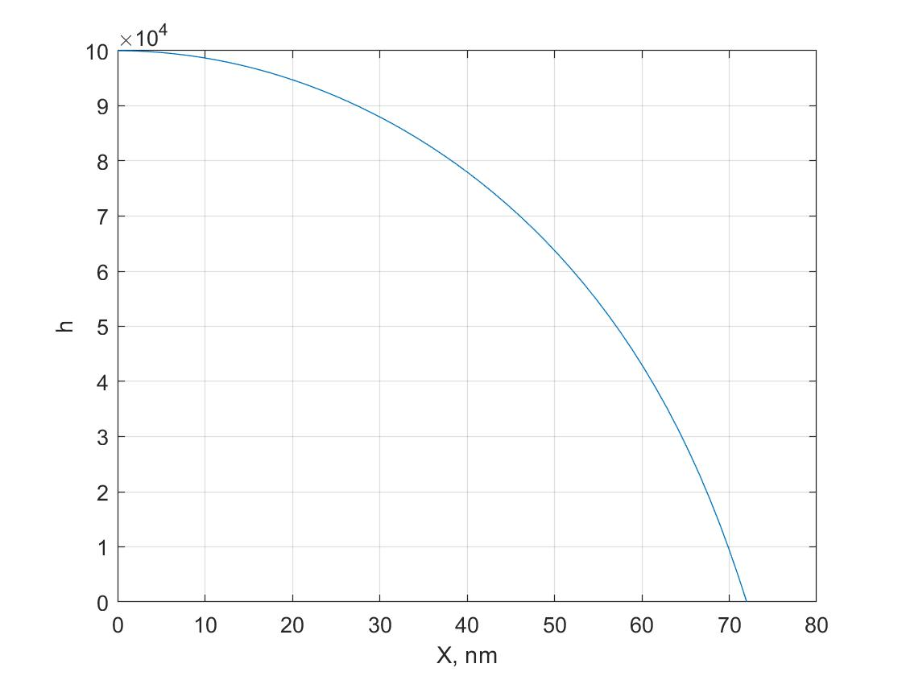

*Flight path angle in degrees*

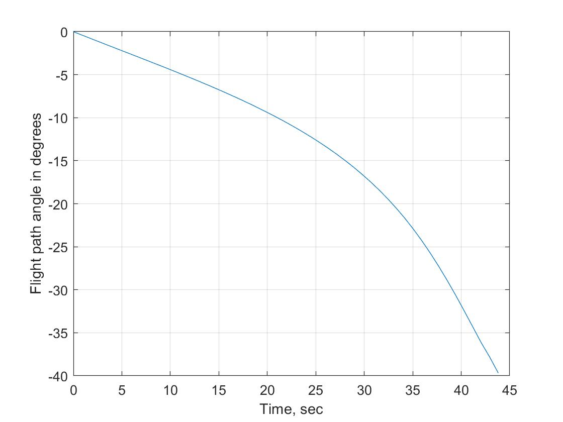

*Flight control vs time*

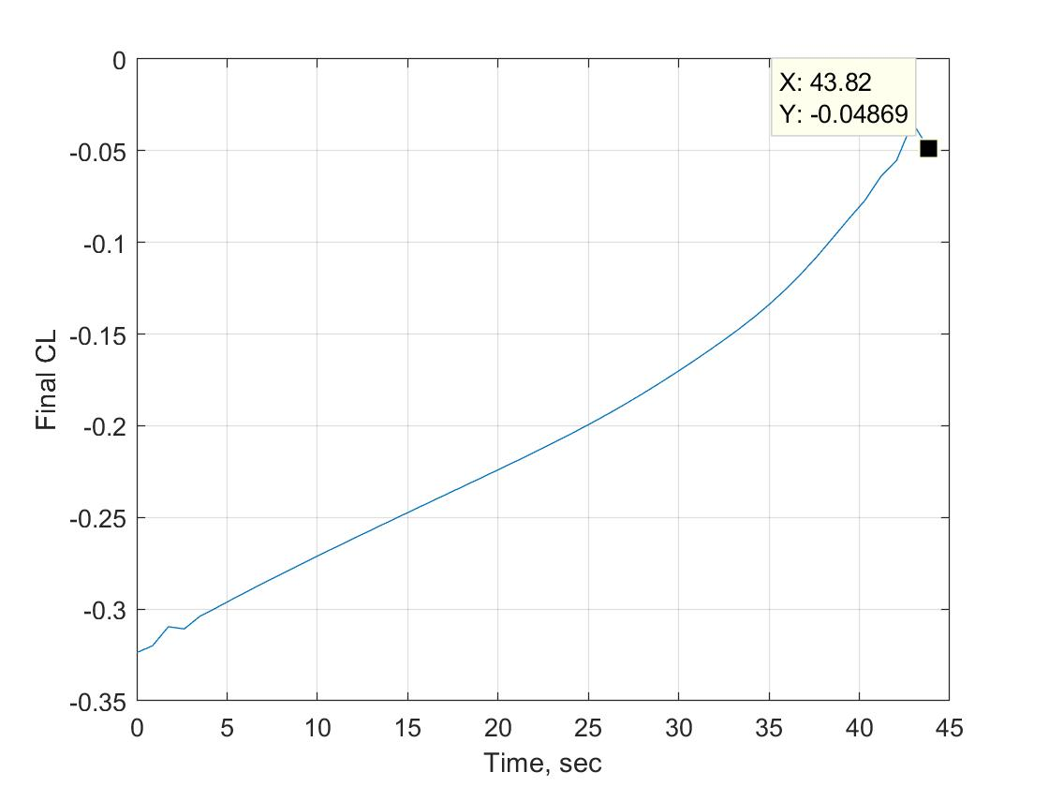

*Velocity as a function of time*

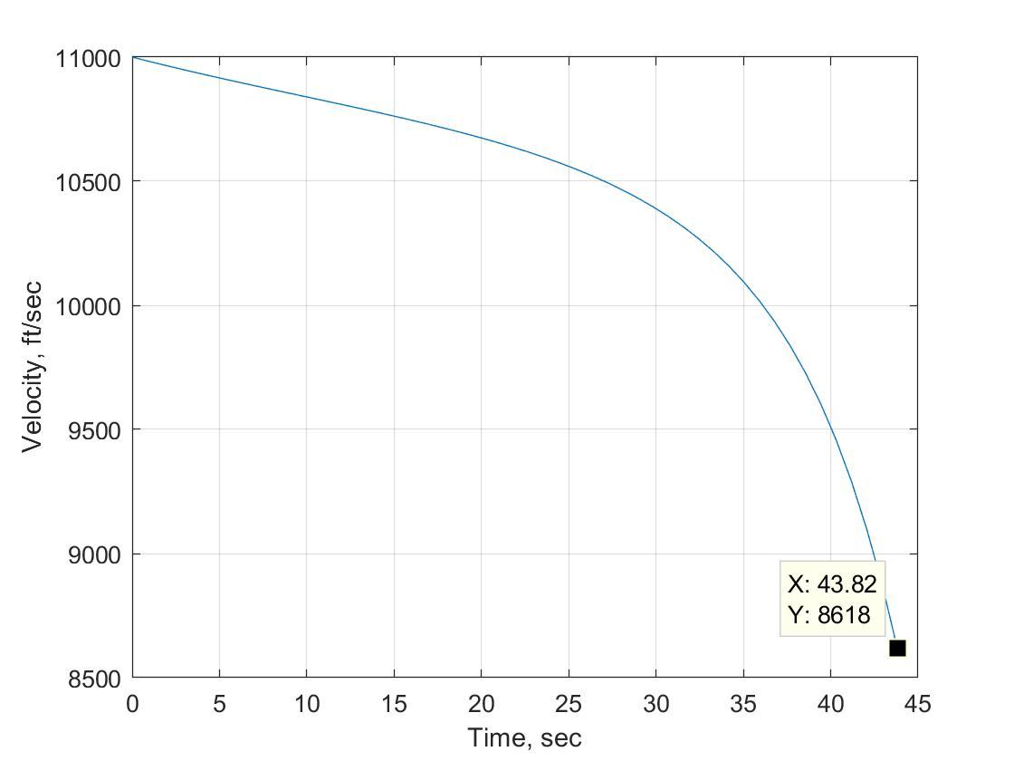

case 2-When the atmospheric density is changed to *0.0023769*1.1* then we get the following plots:

*Height vs distance*

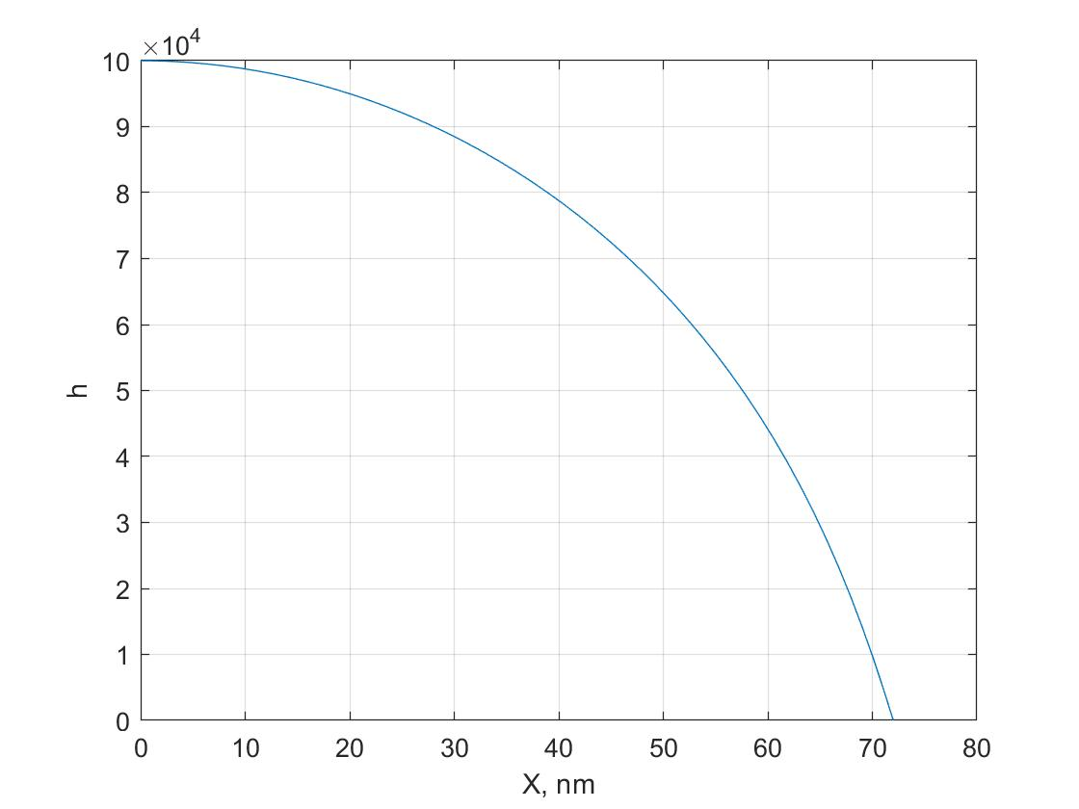

*Flight control vs time*

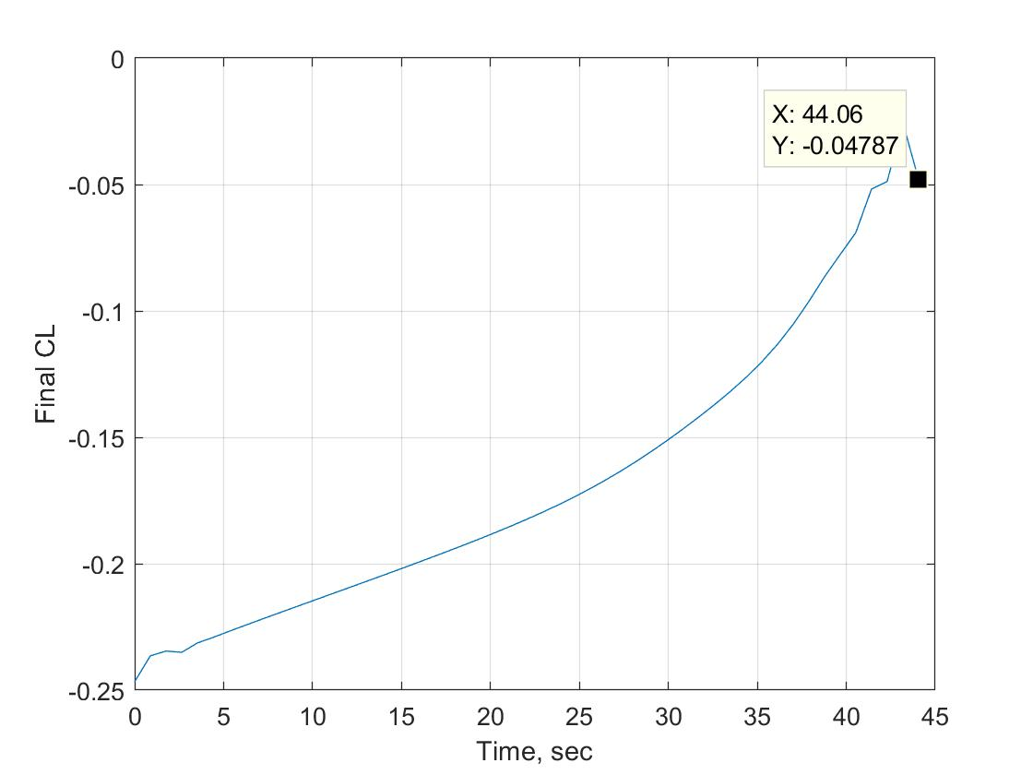

*Flight path angle in degrees*



*Velocity as a function of time*

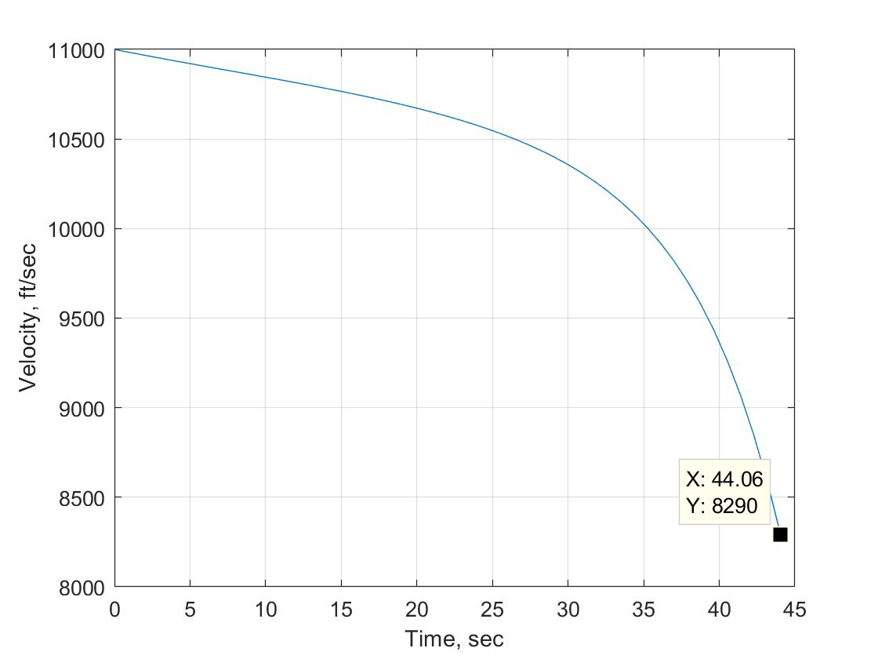

|  |  |  |
| --- | --- | --- |
| **Atmospheric Density** | **Velocity** | **Optimal final time** |
| 0.0023769*0.9 | 8616 | 43.82 |
| 0.0023769*1.1 | 8290 | 44.06 |

Although there is no significant changes in the flight angle but we can see a significant drop of *326 ft/s* in velocity and rise in optimal final time of *0.24s* when the atmospheric density increases.

**Problem 2:**

1. *Simulink diagram*

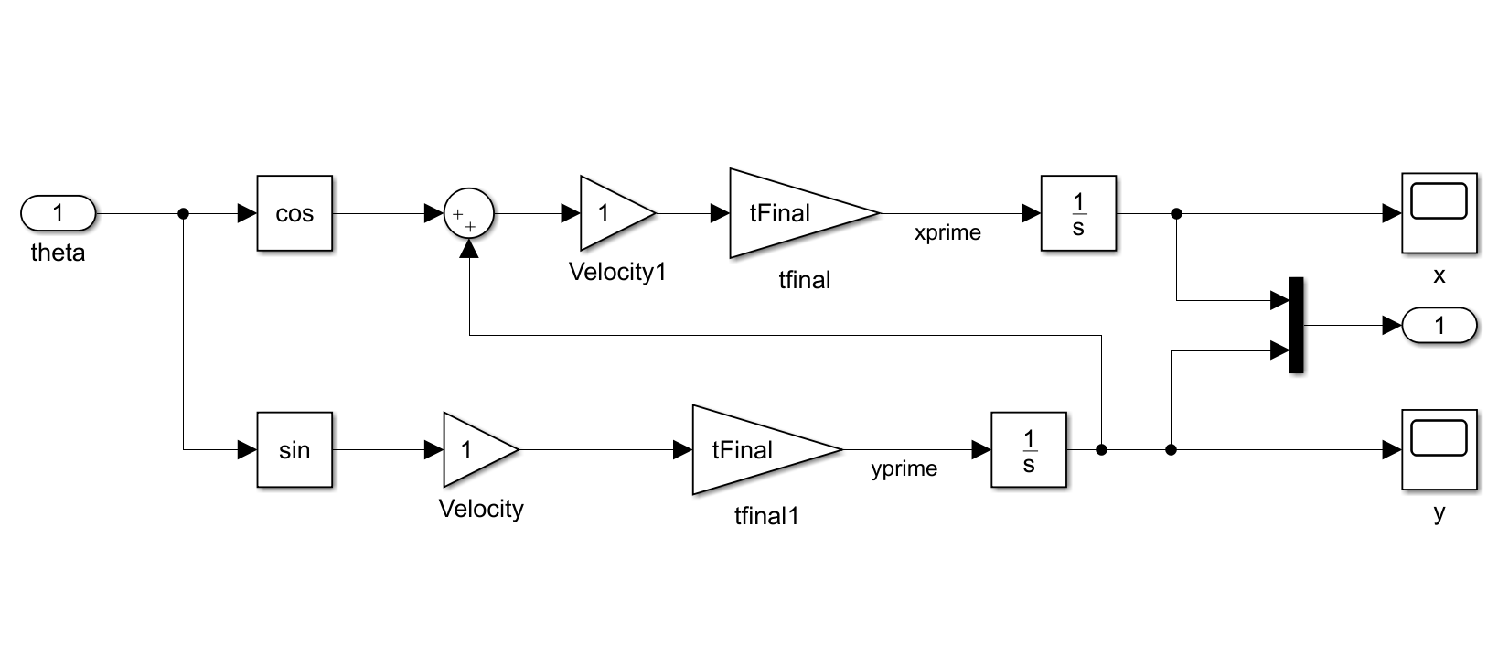

*zermeloMain MATLAB code:*

%% initial guess at tFinal

tFinal = 2.75;

%% tau goes from 0 to 1

tau = 0:0.02:1;

%% initial x

x0 = 4.9;

%% initial y

y0 = 1.66;

%% initial guess at control time history

theta0 = ones(length(tau),1)*(255/57.3);

%% initial guess at final time

theta0(end+1) = tFinal;

%% lower bound on control

lB = ones(length(tau),1)*(-2*pi);

%% upper bound on control

uB = ones(length(tau),1)*pi*2;

%% lower bound on final time

lB(end+1) = 1;

%% upper bound on final time

uB(end+1) = 30;

options = optimset('Display','iter','TolCon',1e-4,'Algorithm','interior-point','PlotFcns','optimplotx','MaxFunEvals',4500);

[thetaFinal, cost] = fmincon('zermeloCost', theta0,[],[],[],[],[],[],'zermeloConstraint',options);

%% optimized final time

tFinal = thetaFinal(end);

%% Optimal time history with optimal control and final time

[tOut,yOut] = sim('zermelo',1,[],[tau' thetaFinal(1:end-1)]);

%% phase plane plot

figure

plot(yOut(:,1),yOut(:,2));

title('phase plane plot');

grid;

xlabel('x');

ylabel('y');

%% plot of optimal control as a function of actual time

figure

plot(tau*tFinal, thetaFinal(1:end-1)*57.3);

xlabel('Final Time');

ylabel('Final Theta in deg');

grid;

s = sprintf('Final Time = %5.3f seconds', tFinal);

title(s)

*zermeloCost MATLAB code:*

function y = zermeloCost(p)

y = p(end);

end

zermeloConstraint MATLAB code:

function [cineq, ceq] = zermeloConstraint(p)

cineq = [];

assignin('base','tFinal', p(end));

tau = [0:0.02:1]';

u = [p(1:end-1)];

[tOut,yOut] = sim('zermelo',1,[],[tau u]);

ceq(1) = yOut(end,1);

ceq(2) = yOut(end,2);

end

*The plots are as follows:*

*The control input vs time*

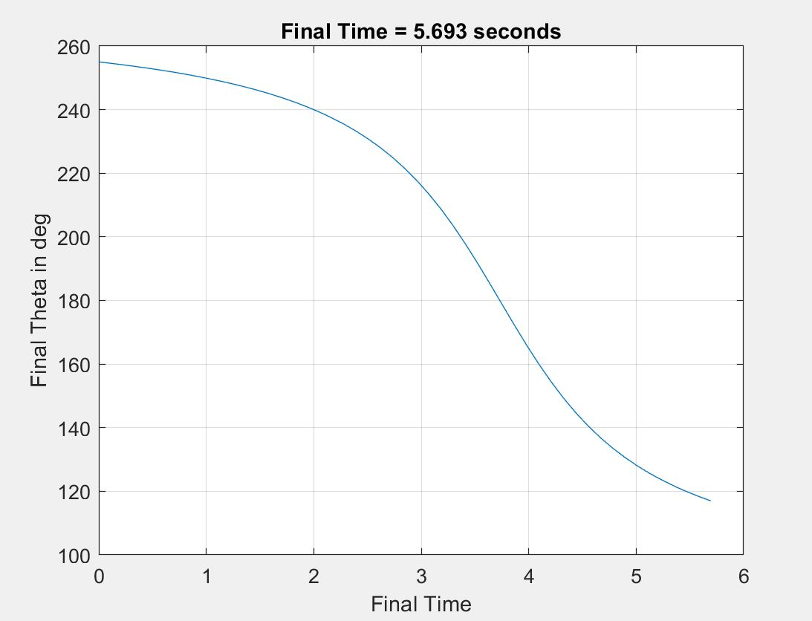

*The trajectory of the boat*

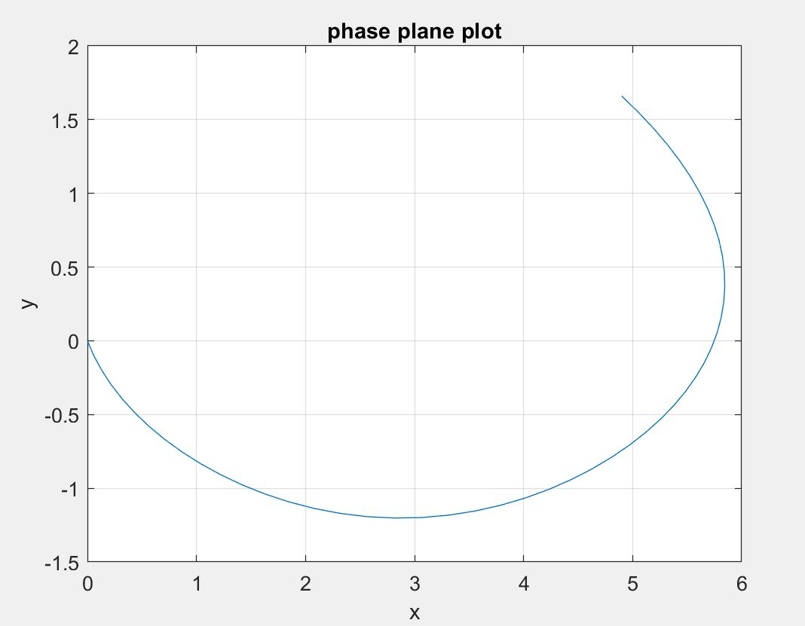

1. Now we need to find the optimization with the y term cubed as shown below:

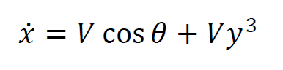

There are no changes in the MATLAB code but there is only a minor change in the Simulink diagram as follows:

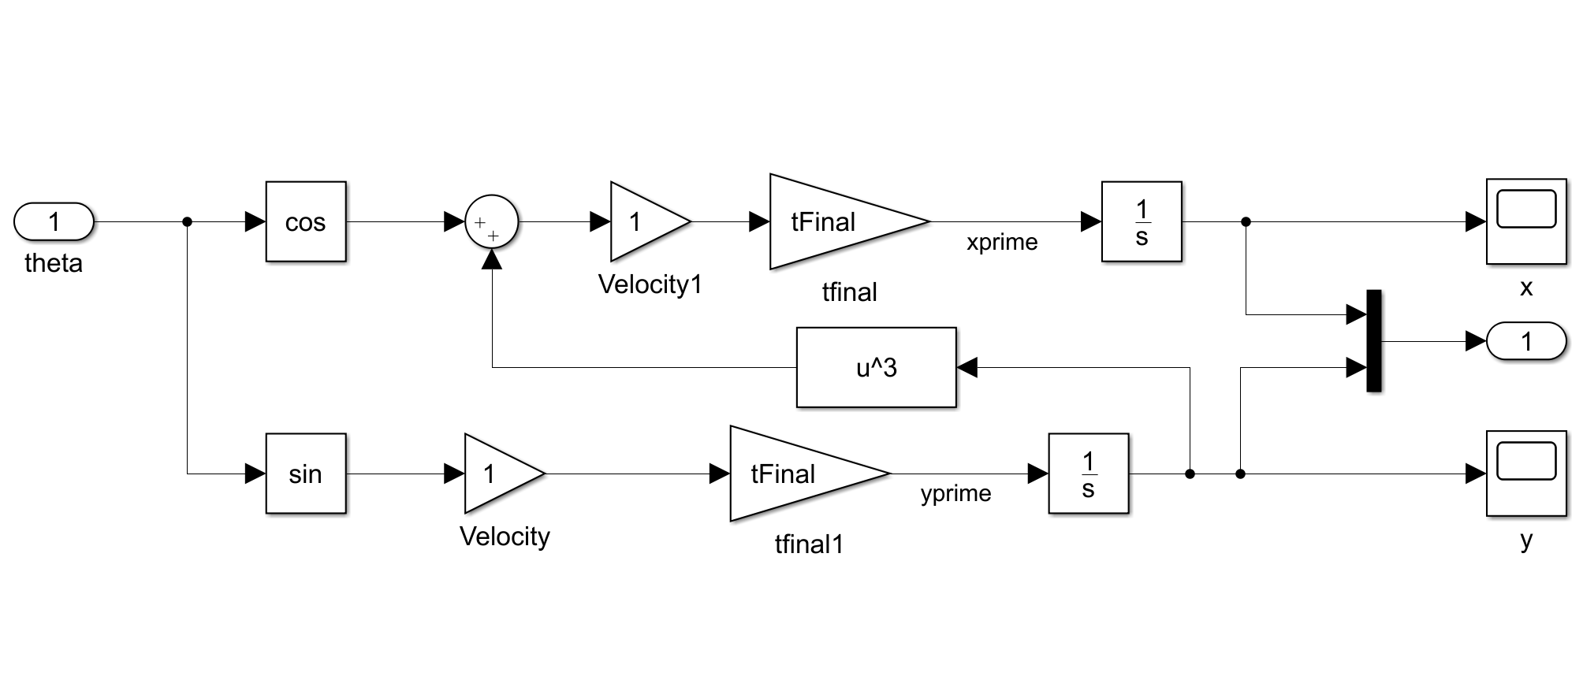

The plots generated will be as follows:

*Control input vs time*

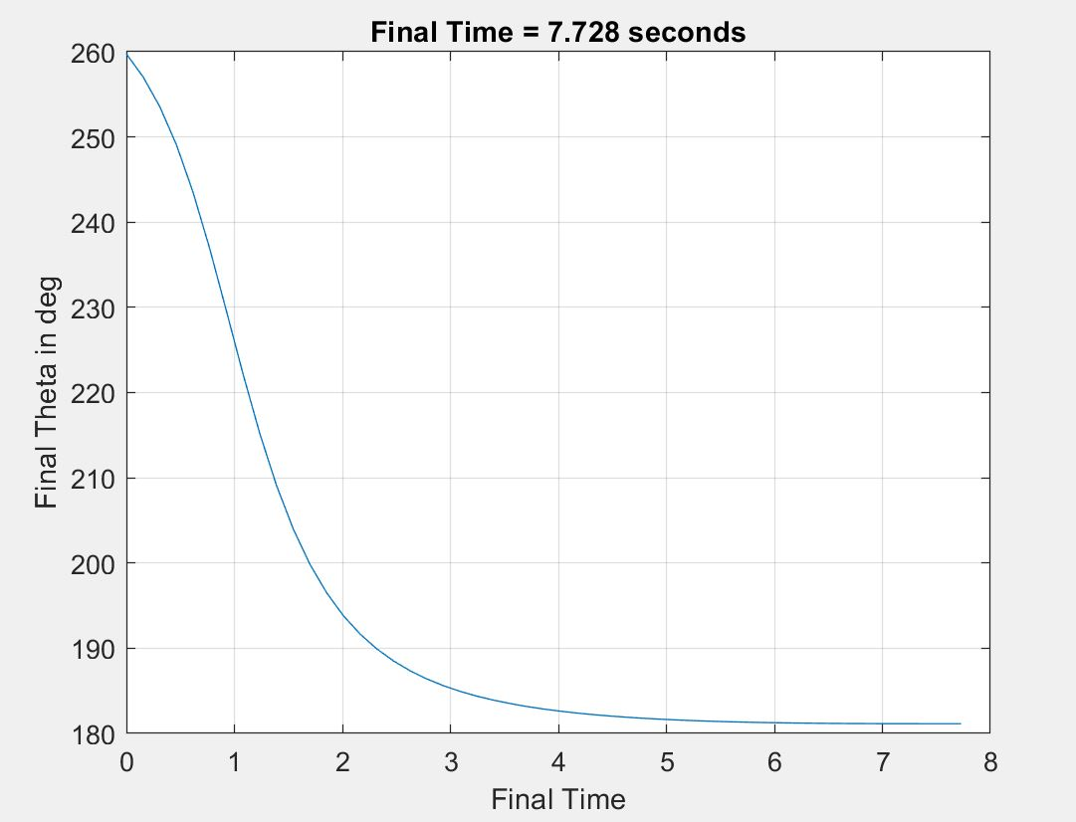

*The trajectory of the boat*

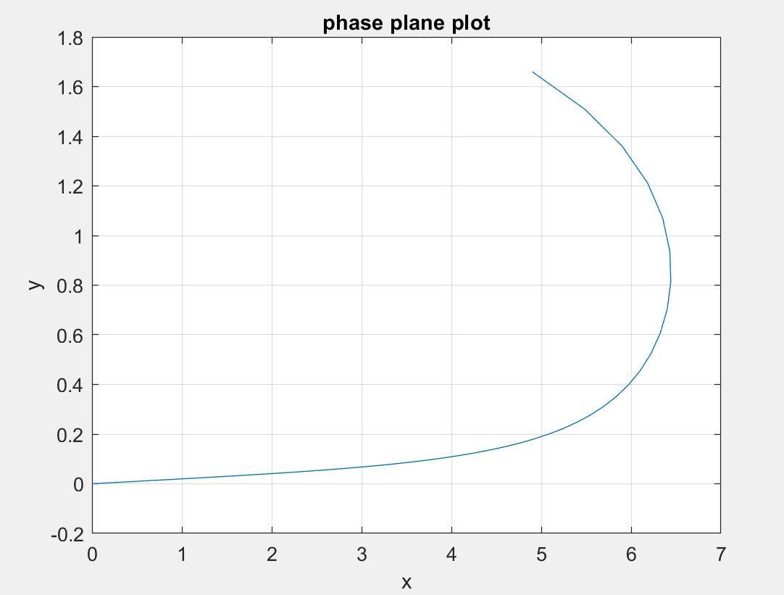

Conclusion:

The effect of y cubed term is that the optimization results in a different final time, the state and control time histories converge quickly as compared to part a. The trajectory of the boat is different as compared to part a because it never crosses the y = 0. The control time history smoothly settles to the final theta value as compared to case a. The final time after optimization is greater than the one obtained in the case a.